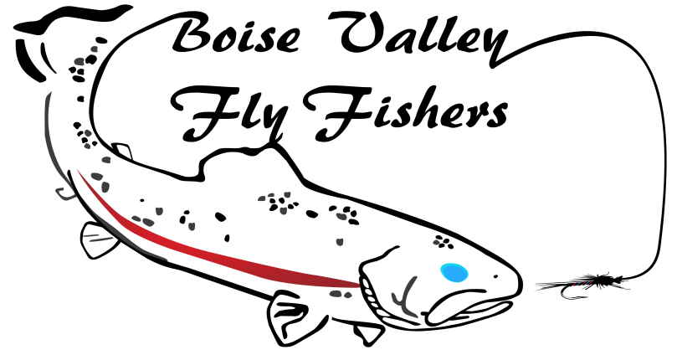

Popper Slam Guidelines

Goal: Catch and release a Largemouth Bass, a Smallmouth Bass, a Bluegill, and a Crappie using a top water fly (examples include but not limited to popper, foam spider, foam frog, mouse patterns, stimulator, etc.) and fly tackle.
Rules
- The fish must be photographed with minimal stress. (We recommend using the Keep’em wet method, see www.keepemwet.org for principles and tips).
- The fish must be caught on a single barbless fly, using fly fishing tackle. A photo of the fly must be submitted with the documentation.
- Application must include Popper Slam Log Sheets with pictures.
- Applicant must be a member in good standing to qualify for the award.
- All fish must be caught and posted after the challenge program start date of 5/9/2019.
How to Apply
Send documentation and photographs to:
Boise Valley Fly Fishers
P.O. Box 311
Boise, ID 83701

